

**HTML Assignment -** Class 6

**Previous Class: Working with Multimedia Objects**

**Today Assignment: Making consistent layout using Template**

**Time: 15 minutes**

**Template requirement:**

**Pass requirement: 4 / 10 points**

1. Create following page using div and span combine with CSS:

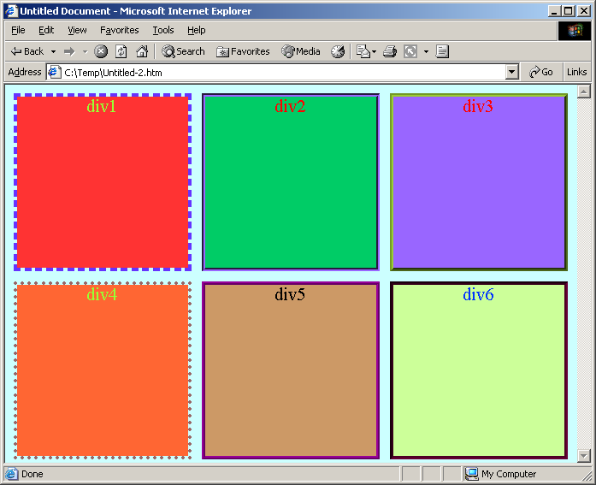

* 1. Create square boxes with background color: 4 points
  2. Use CSS to make boxes separate from each other: 2 points
  3. Create border for boxes: 2 points
  4. Make border outside the boxes as per screenshot: 2 points